1. ABOUT PROJECT

This project aims at detecting Alzheimer's Disease using Brain MRI scans and classifying its stage, using Deep Learning. This is done using a variety of tools, libraries and modules. This project was written and compiled on Visual Studio using iPython Notebook on Windows 11 OS.

1. PRE-REQUISITES OF PROJECT

Tested support for OS: Windows 11, Mac 10.15.7, Ubuntu 20.04 LTS

Softwares/Frameworks Used:

* Python 3.10
* Visual Studio Code
* HTML 5
* CSS 3
* Bootstrap 5.2
* JavaScript ES2015
* iPython 7.12.0
* Flask 2.1.2 (Python)
* Werkzeug 2.1.2 (Python)
* NumPy 1.22.0 (Python)
* TensorFlow 2.8.0 (Python)
* Matplotlib 3.5.1 (Python)
* OpenCV 4.5.5 (Python)
* Imbalanced-learn 0.9.1 (Python)
* Scikit-Learn 1.1.1 (Python)
* Seaborn 0.11.2 (Python)

Softwares/Frameworks Required To Run:

* iPython 7.12.0
* Flask 2.1.2 (Python)
* Werkzeug 2.1.2 (Python)
* NumPy 1.22.0 (Python)
* TensorFlow 2.8.0 (Python)

1. THEORY
   1. Alzheimer’s Disease:

Alzheimer’s disease is a brain disorder that slowly destroys memory and thinking skills and, eventually, the ability to carry out the simplest tasks. In most people with the disease — those with the late-onset type symptoms first appear in their mid-60s. Early-onset Alzheimer’s occurs between a person’s 30s and mid-60s and is very rare. Alzheimer’s disease is the most common cause of dementia among older adults.

The disease is named after Dr. Alois Alzheimer. In 1906, Dr. Alzheimer noticed changes in the brain tissue of a woman who had died of an unusual mental illness. Her symptoms included memory loss, language problems, and unpredictable behavior. After she died, he examined her brain and found many abnormal clumps (now called amyloid plaques) and tangled bundles of fibers (now called neurofibrillary, or tau, tangles).

These plaques and tangles in the brain are still considered some of the main features of Alzheimer’s disease. Another feature is the loss of connections between nerve cells (neurons) in the brain. Neurons transmit messages between different parts of the brain, and from the brain to muscles and organs in the body. Many other complex brain changes are thought to play a role in Alzheimer’s, too.

This damage initially takes place in parts of the brain involved in memory, including the entorhinal cortex and hippocampus. It later affects areas in the cerebral cortex, such as those responsible for language, reasoning, and social behaviour. Eventually, many other areas of the brain are damaged.

Computer generated graphics of a Normal brain and an affected brain with labels pointing to the cerebral cortex and the hippocampus:

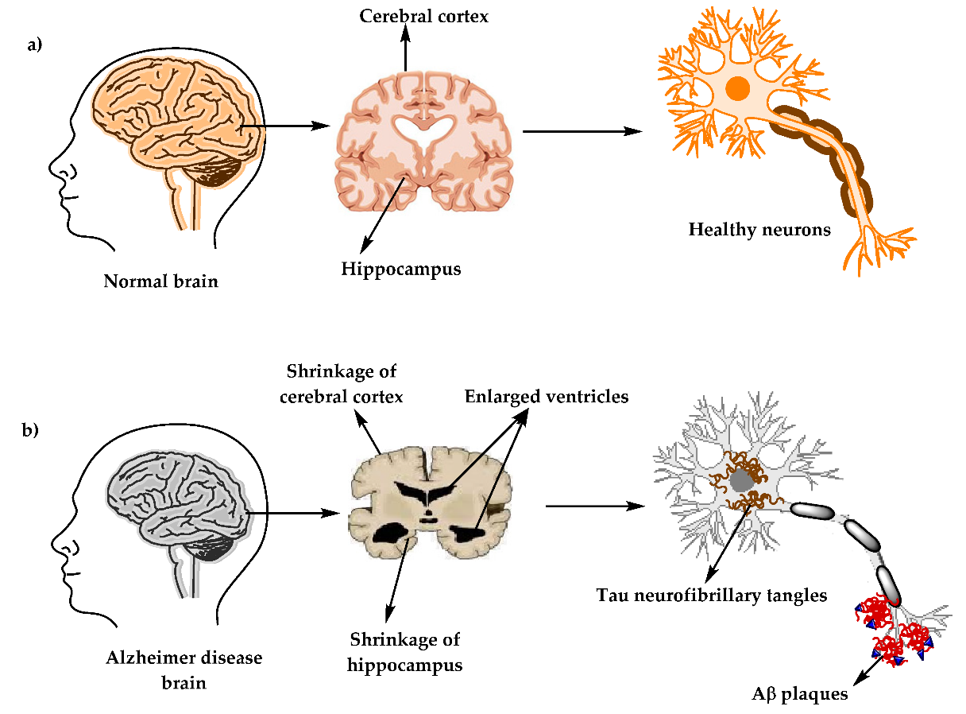

* 1. Magnetic Resonance Imaging:

Magnetic resonance imaging (MRI) is a medical imaging technique that uses a magnetic field and computer-generated radio waves to create detailed images of the organs and tissues in your body.

Most MRI machines are large, tube-shaped magnets. When you lie inside an MRI machine, the magnetic field temporarily realigns water molecules in your body. Radio waves cause these aligned atoms to produce faint signals, which are used to create cross-sectional MRI images — like slices in a loaf of bread.

The MRI machine can also produce 3D images that can be viewed from different angles.

A special type of MRI is the functional MRI of the brain (fMRI). It produces images of blood flow to certain areas of the brain. It can be used to examine the brain's anatomy and determine which parts of the brain are handling critical functions.

This helps identify important language and movement control areas in the brains of people being considered for brain surgery. Functional MRI can also be used to assess damage from a head injury or from disorders such as Alzheimer's disease.

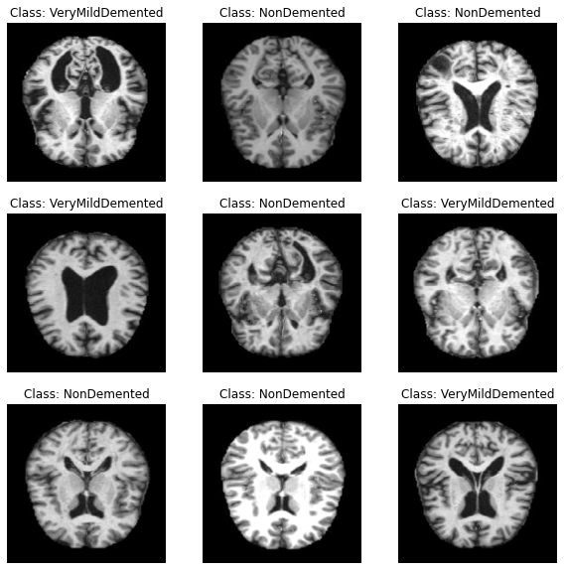

1. MODULES OF PROJECT

The project comprises of 3 modules:

* 1. Data Acquiring and Preprocessing:
     1. Data acquired from Kaggle user [Sarvesh Dubey](https://www.kaggle.com/tourist55), who provided a dataset consisting of 6000+ MRI images belonging to four classes of images both in training as well as a testing set:
        1. Mild Demented,
        2. Moderate Demented,
        3. Non-Demented,
        4. Very Mild Demented.
     2. Used [ImageDataGenerator](https://www.tensorflow.org/api_docs/python/tf/keras/preprocessing/image/ImageDataGenerator) (TensorFlow) to augment the images from the Training Dataset and form new training samples in real-time while the model is still training.
     3. Performed over-sampling of the data using [SMOTE](https://imbalanced-learn.org/stable/references/generated/imblearn.over_sampling.SMOTE.html) to eliminate the class imbalance in the Training dataset.
  2. Model Training and Evaluation:
     1. Model architecture:

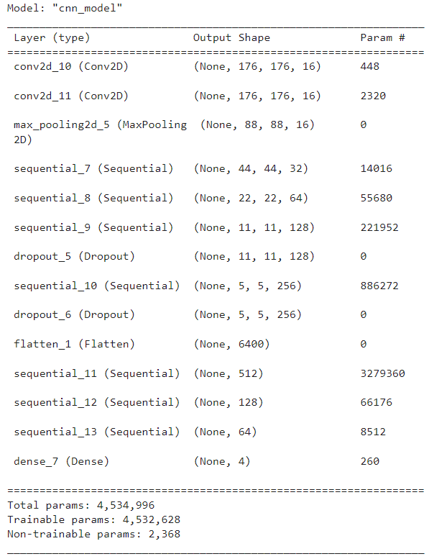

* + 1. Model trained for 100 epochs, with a validation split of 20%, resulting in:

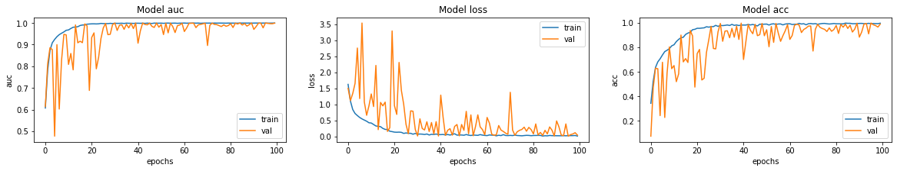

* + 1. When tested on previously unseen data (~1500 images), the results were: loss: 1.9561, acc: 0.6435, auc: 0.8288
    2. It was observed from the confusion matrix that the model was a little confused with Very Mildly Demented and Non-demented samples.

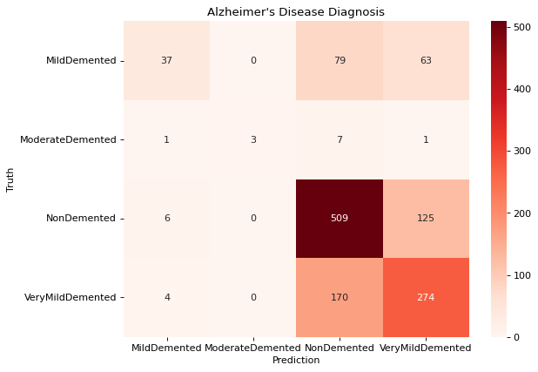

* 1. Flask App:
     1. An HTML page is rendered through Flask to retrieve User-MRI file through a form.
     2. The HTML template is adorned using CSS, Bootstrap, Google Fonts, icons from [Icon8](https://icons8.com/), background video from [Pexels](https://www.pexels.com/), and JavaScript.
     3. The MRI image file is converted to an image array of suitable dimensions for the model to work upon.
     4. The model classifies a type of Dementia (from the previously mentioned 4 classes) and the output is printed both on the webpage and the terminal.
     5. The image file is also saved to the device for future uses.

1. DATA FLOW DIAGRAM

